Shammah Thao

2/19/20

CPE 138 sec 1

Lab 1: Wireshark

1. 3 different protocols that appears is TLSv1.2, TCP and HTTP.

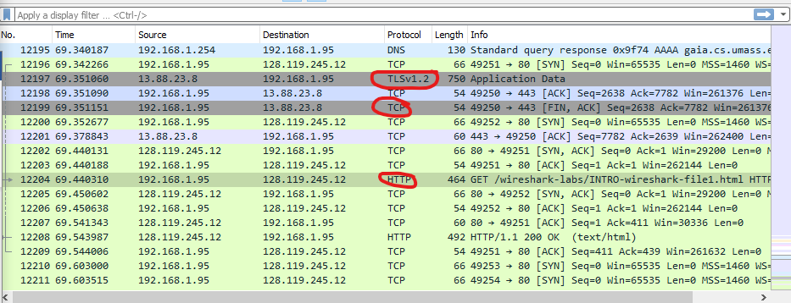

1. 69.543987 – 69.440310 = 0.103677

It took 0.103677 sec for HTTP Get to get to HTTP ok.

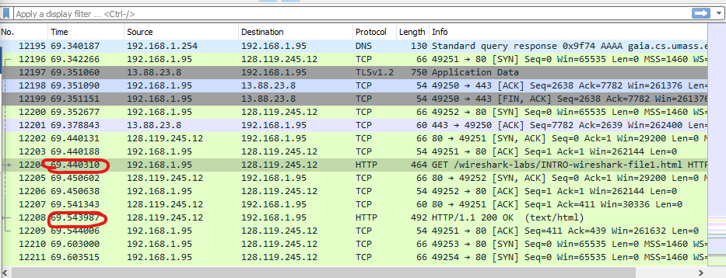

1. Gaia.cs.umass.edu : 12.119.245.12

My internet address: 192.168.1.95



HTTP GET:

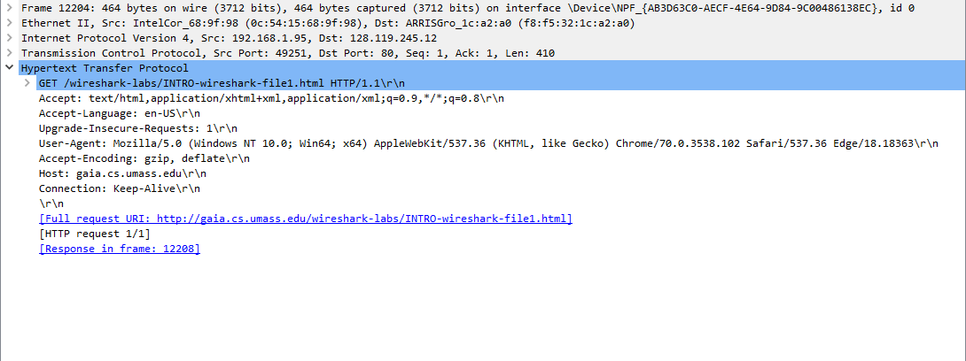

HTTP OK:

